**Course End Project**

**Spring boot Application Containerization using Reusable Workflow with Caching**

**Step 1: Log in to GitHub.com**

1. Sign in to the GitHub portal at <https://github.com>
2. Navigate to your repository main page where we are going to create a workflow file.

**<https://github.com/ashishsinghamethi/MavenBuild29Sep.git>**

**Step 2: Create a new workflow file to implement the reusability and caching mechanism.**

1. Once you are on the GitHub main repository page, we can start creating a new Workflow file.
2. Create a .github/workflows directory in your repository in case the directory does not exist.
3. In the workflow directory, create a new workflow file with the name maven-cache.yml.
4. Add below workflow content in the above created file.

**name: Docker image Build Process**

**on:**

**workflow_dispatch:**

**workflow_call:**

**secrets:**

**DOCKERHUB_USERNAME:**

**required: true**

**DOCKERHUB_PASSWORD:**

**required: true**

**jobs:**

**docker:**

**env:**

**appName: "springboot-image"**

**runs-on: ubuntu-latest**

**steps:**

**- name: Checkout**

**uses: actions/checkout@v3**

**- name: Set up JDK 11**

**uses: actions/setup-java@v3**

**with:**

**java-version: '11'**

**distribution: 'temurin'**

**cache: maven**

**- name: Build with Maven**

**run: mvn -B package --file pom.xml**

**- name: Set up Docker Buildx**

**uses: docker/setup-buildx-action@v2**

**- name: Login to Docker Hub**

**uses: docker/login-action@v2**

**with:**

**username: ${{ secrets.DOCKERHUB_USERNAME }}**

**password: ${{ secrets.DOCKERHUB_PASSWORD }}**

**- name: Build and push**

**uses: docker/build-push-action@v4**

**with:**

**context: .**

**push: true**

**tags: ${{ secrets.DOCKERHUB_USERNAME }}/${{ env.appName }}:latest**

1. Once the file is created, click on Commit new file to save the workflow file in your code repository.

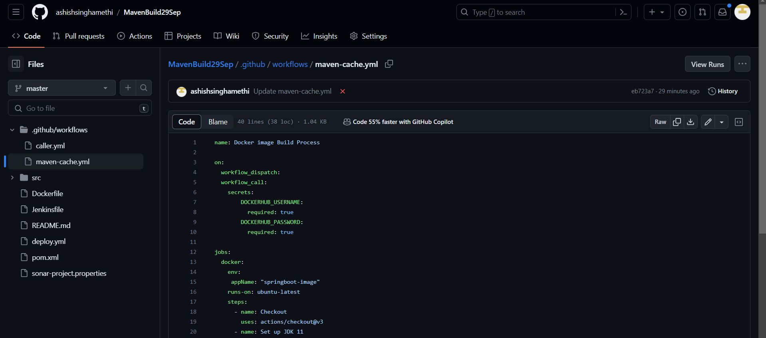

1. Next, we have to create a caller.yml which is going to invoke Reusable workflow as per the below content:

name: Reusable Workflow Caller

on:

push:

jobs:

Reusable-caller-job:

uses: ./.github/workflows/maven-cache.yml

secrets:

DOCKERHUB_USERNAME: ${{ secrets.DOCKERHUB_USERNAME }}

DOCKERHUB_PASSWORD: ${{ secrets.DOCKERHUB_PASSWORD }}

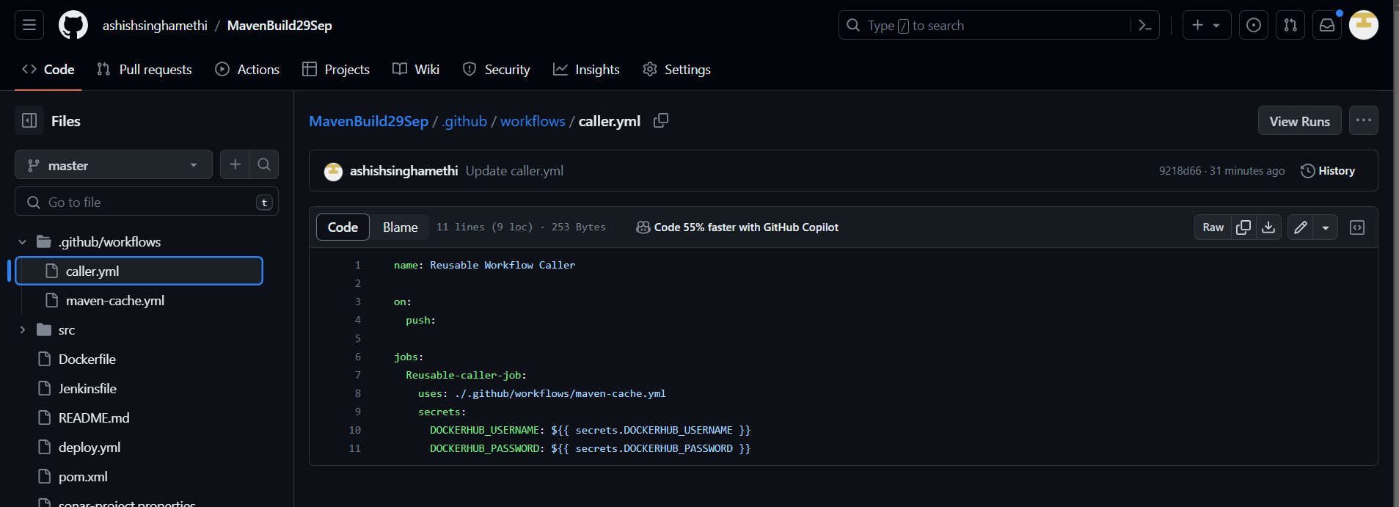

1. Next to test our event, we can go to code from your repository and start performing some code changes.
2. This will invoke workflow automatically, navigate to the Actions tab on your repository to access the workflow execution page as below:

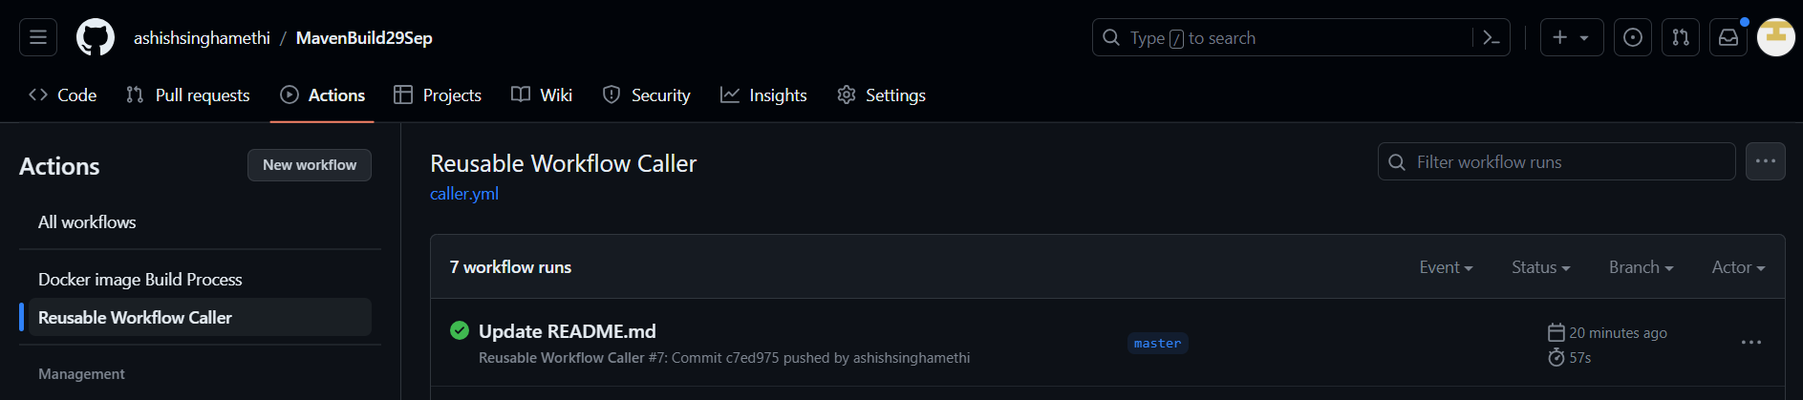

1. From the left sidebar you can select the workflow to access execution logs.

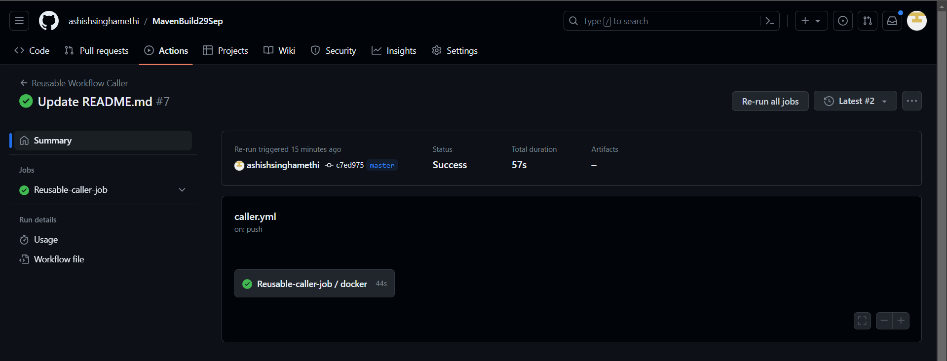

1. Select the latest workflow execution run to access execution logs for the jobs configured in the workflow.
2. Click on Basic-Workflow to access jobs logs, you can also expand different steps execution logs to get detailed information regarding jobs executions.

